**Explore Effects of Buses on Discharged Rate of Intersections**

**Based on pNEUMA Data**

Lin Lyu and Qing Tang

1. **Background and Goals**

Curbside bus stops are commonly located short distances from signalized intersections, in part to facilitate passenger transfers between perpendicular bus lines (Fitzpatrick et al., 1996[1]). The bus stop may reside upstream of its neighboring intersection (a so-called near-side stop) or downstream of it (a far-side stop). In either case, buses may occupy a travel lane while dwelling at the stop to load and unload passengers. A dwelling bus can therefore become a bottleneck that constrains car flows near the intersection. Existence of buses changes the average saturation headway which has an impact on the discharge flow of intersections when the traffic signal turns green. This can cause car queues to expand, which can further delay the buses as well as the cars. The goal of the project is to explore how the existence of buses affect discharge rate of intersections, more specifically, exploring the relationship between bus ratio during a specific period and the discharge rate.

1. **Dataset**

pNEUMA is an open large-scale dataset of naturalistic trajectories of half a million vehicles that have been collected by a one-of-a-kind experiment by a swarm of drones in the congested downtown area of Athens, Greece[2].

A swarm of 10 drones hovering over the central business district of Athens over multiple days to record traffic streams in a congested area of a 1.3 km2 area with more than 100 km-lanes of road network, around 100 busy intersections (signalized or not), more than 50 bus stops and close to half a million trajectories. The aim of the experiment is to record traffic streams in a multi-modal congested environment over an urban setting using Unmanned Aerial Systems (UAS) that can allow the deep investigation of critical traffic phenomena.

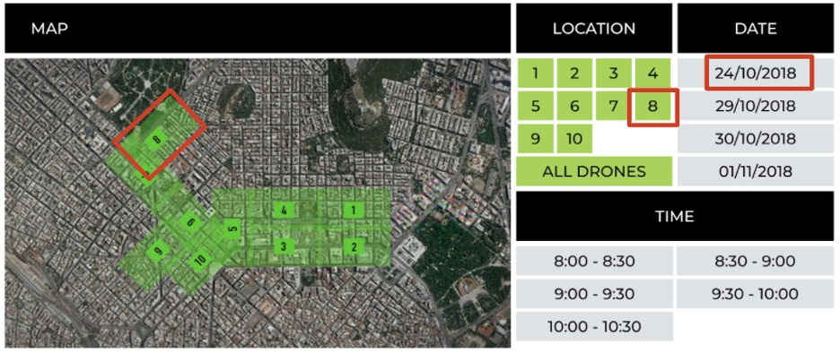

Figure 1. Data Overview

1. **Data Structure**

The original dataset is csv files where each row is a trajectory of a specific type of vehicle with a unique track ID. We can see from Table 1, different unique track IDs have information of vehicle type, distance traveled in meters and average speed of the vehicle in km/h.

Table 1. Information with track ID

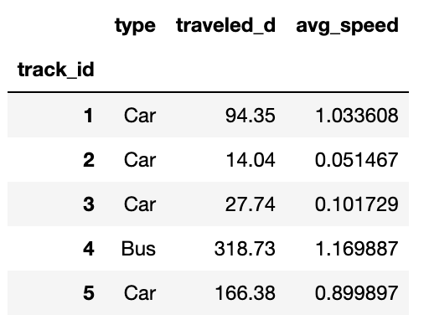

For each track ID, it has information about time in seconds with a frame of 0.04s, latitude of the vehicle, longitude of the vehicle, speed in km/h, longitudinal and lateral acceleration in m/sec2.

Table 2. Information for a specific track ID.

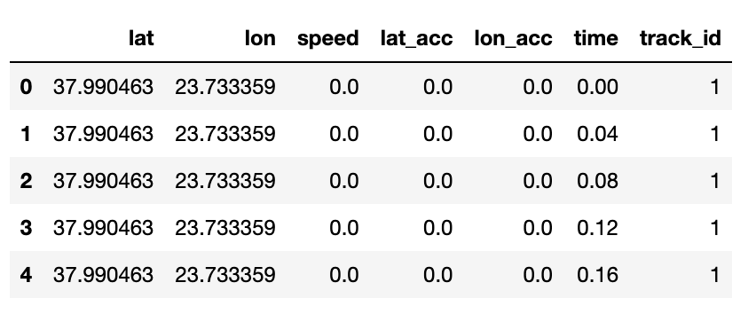

1. **Methodology**

In this part, firstly we explained the data used for the project and how we deal with the data preprocessing and data filtering to extract useful information. Then we generated the time space diagram for finding the location of the signal and estimated the saturation flow rate when the signal changes from red to green. Finally, we use linear regression to find the relationship between bus ratio and saturation flow rate.

**4.1 Study Area**

We used data from drone 8 collected from 8:30 AM to 11:00 AM on October 24th 2018, in the intersection 28is Oktovriou and Leof Alexandras, seen from Figure 2. We can see Figure 3 shows all the data points collected during the study period with coordinates of longitude and latitude.

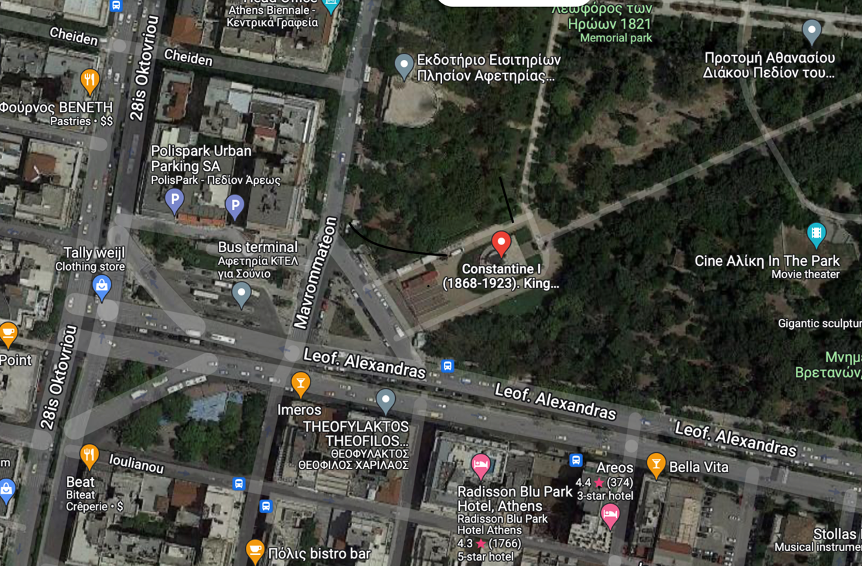

Figure 2. Intersection from google map view

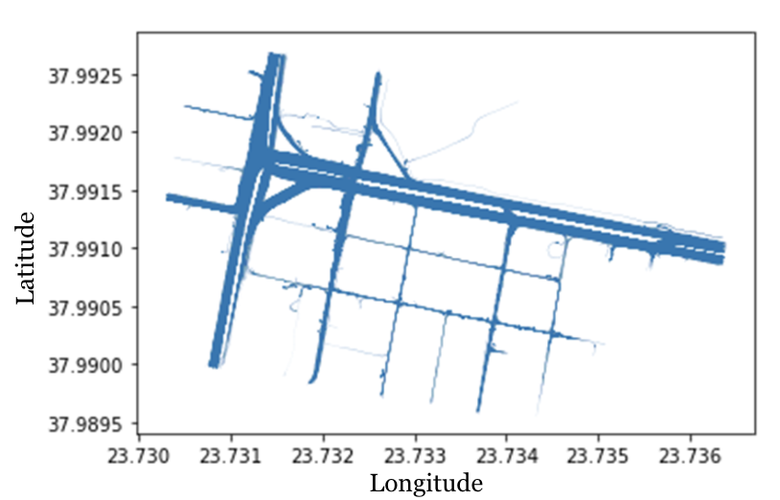

Figure 3. Visualization of all data points during the study period

**4.2 Data Preprocessing**

In order to plot the time space diagram, we firstly need to change the latitude and longitude coordinates in GPS to XY coordinates with meter units shown in Figure 4. The process of converting GPS data into XY coordinates is summarized as follows.

Step 1: Finding a reference point with latitude (ref_lat) and longitude (ref_lat), then transfer the latitude and longitude to degree (ref_lat_rad and ref_lat_rad)

Step 2: Transfer every point from latitude to longitude coordinates to degree (lat_rad and lon_rad)

Step3: c=arccos(sin(ref_lat_rad)*sin(lat_rad)+cos(ref_lat_rad)*cos(lat_rad)*cos)(lon_rad-ref_lon_rad)

k=c/sin(c)

Step 4: Converting XY coordinates in meters using following formulas.

x=k*(cos(ref_lat) * sin(lat) - sin(ref_lat)* cos(lat)* cos(lon_rad - ref_lon_rad))*radius of earth

y=k*cos(lat)*sin(lon_rad-ref_lon_rad)*radius of earth

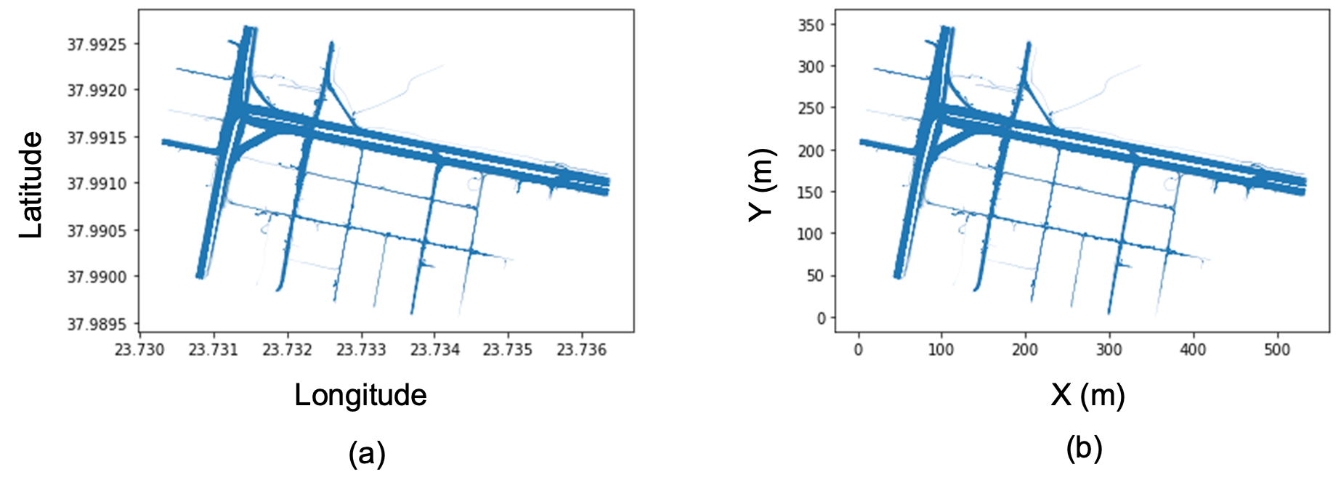

Figure 4. Transferring data in GPS coordinates (a) into local XY coordinates (b).

After converting, we found that the roadway is not parallel to the X axis or the Y axis. It is difficult to filter the data of an area we would like to analyze. Then we rotated the XY to X1Y1, in which the roadway is parallel to the X1 and the Y1 axis, shown in Figure 5. We measured and estimated the angle of inclination, $θ=12$ degrees, from google map. Using the following equations, we can rotate the Figure 5(a) to Figue 5(b).

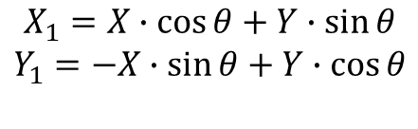

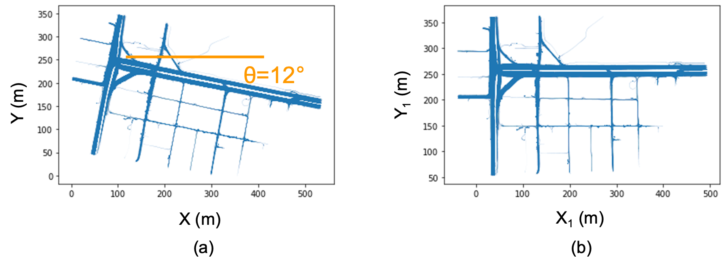

Figure 5. Process of data preprocessing

More data details could be seen from Table 3, from original coordinates latitude and longitude, to XY coordinates and rotated X1Y1. The left side table contains all the time frames of each track ID with GPS coordinates, speed, acceleration, time, XY and X1Y1 coordinates. The right side table presents the vehicle type for each track ID.

Table 3. Data after preprocessing

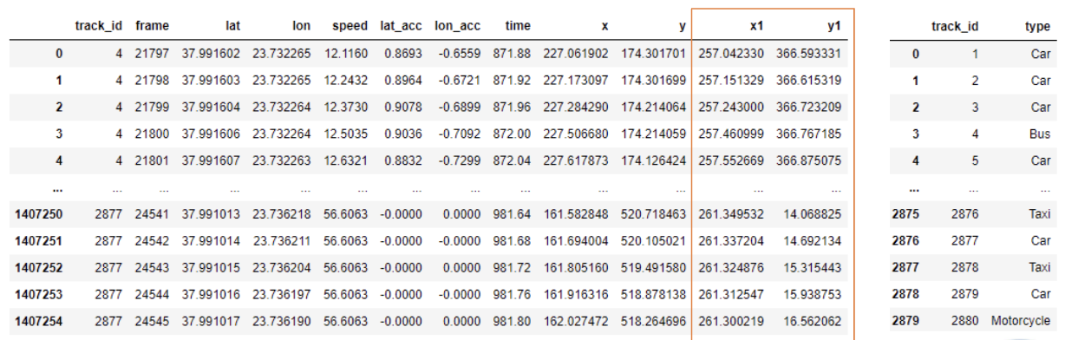

We selected a specific roadway segment with one direction to analyze the saturation flow rate. The yellow rectangle area in Figure 6 is our selected roadway segment with three lanes in one direction. In order to filter the dataset from the selected segment, we labeled four points ABCD in Google map to get the GPS coordinates. These four points ABCD with GPS coordinates were transferred to X1Y1 coordinates through previous processes. We used these four points as constraints to filter the data.

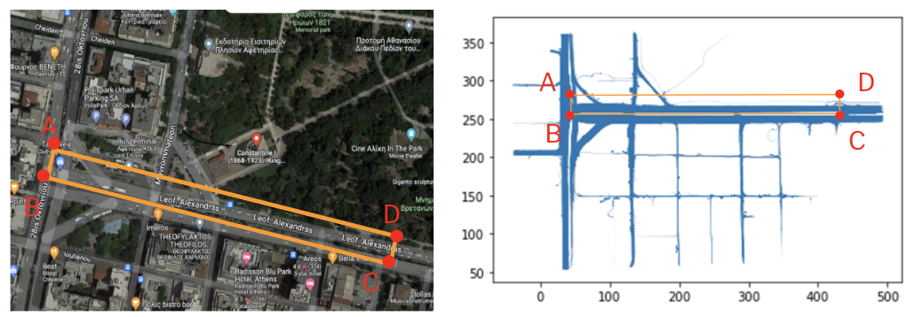

Figure 6. Study roadway segment.

**4.3 Time Space Diagram**

The selected roadway segment is demonstrated in Figure 7. We can find that the segment has three lanes, and it turns to four lanes at the intersection. Then we plotted the time space diagram shown in Figure 8.

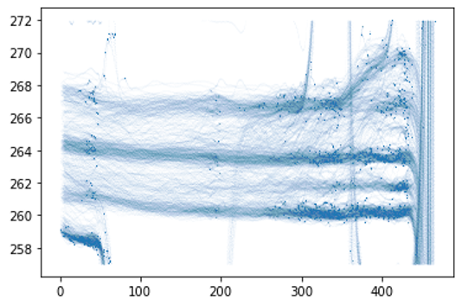

Figure 7. Visualization of the selected roadway segment.

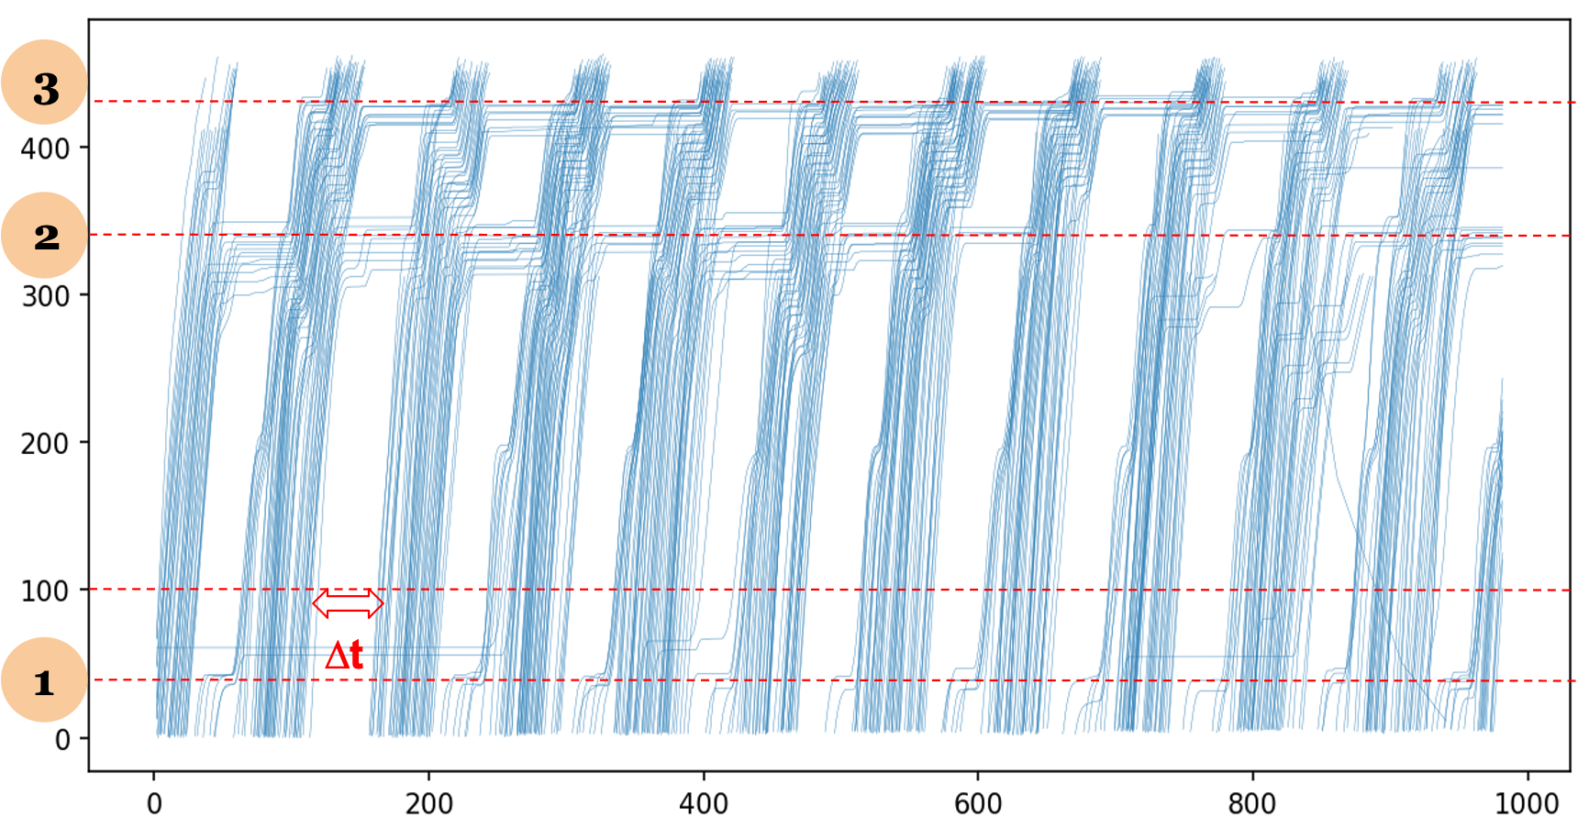

Figure 8. Time space diagram

From the time-space diagram, we can see that there exists three intersections with signals. The distance between the second and the third intersections is about 100 m. It is difficult to estimate the saturation flow rate at the second intersection since it is easily affected by the backward wave produced at the third intersection. Therefore, we selected the first intersection to analyze the relationship between saturation flow rate and bus ratio. There are 10 complete signal cycles in total.

**4.4 Saturation Flow**

At the first intersection, we selected an downstream point at 100 m as an observation point. Our objective is to count the number of vehicles passing this observation point in each signal cycle. We selected those vehicles passing the observation point and obtained the time passing the point, denoted as time_100. Then the data is sorted by the time passing the observation point in ascending order. We got updated indexes to denote the vehicle from left to right in the time-space diagram. The time difference between two consecutive vehicles at the observation location was calculated and denoted as diff in Table 4. There are 13 vehicles with a time difference greater than 18 seconds. They are significantly greater than other points with a time difference less than 5.8 seconds. Two vehicles with unexpected trajectories were deleted. Then we sorted the time passing the observation point in ascending order, and got 11 indexes (34, 87,..., 552) shown in Table 5. These indexes denote the last vehicle passing the observation point in each signal cycle. As such, we can get the number of vehicles in each signal cycle ( $n_{1}, n_{2 }, ..., n_{10})$ to calculate the average discharging rate as our estimated saturation flow rate. Table 6 presents the saturation flow rate and the vehicle ratio of different type vehicles for each cycle.

Table 4. The time difference between two consecutive vehicles

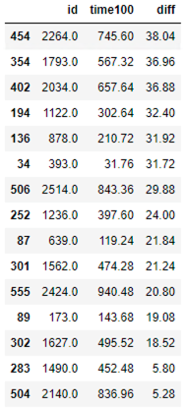

Table 5. Last vehicles passing the observation point

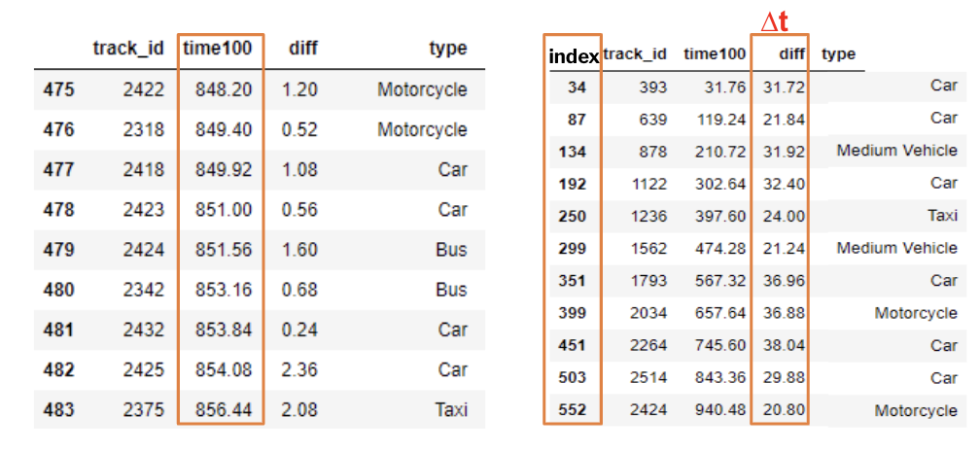

Table 6. Data with calculated number of vehicles for different vehicle types per cycle.

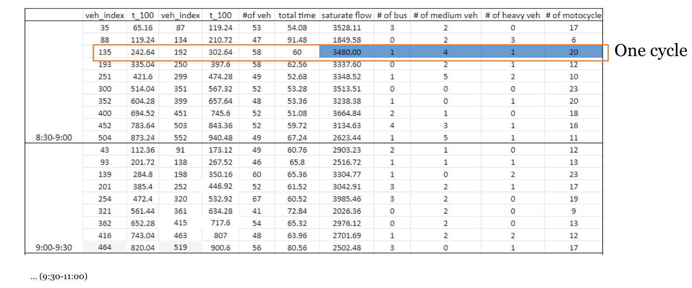

**4.5 Numerical Analysis**

Before building models based on the filtered data we have, we firstly implement some exploratory analysis. There are five types of vehicles in the dataset: passenger cars, bus, heavy vehicles, medium vehicles, motorcycles. We then plot the number of vehicles for different vehicle types of each cycle, seen Figure 9, with x axis as cycles, where we can see cars and motorcycles dominate while there are not lots of buses, heavy vehicles and medium vehicles per cycle.

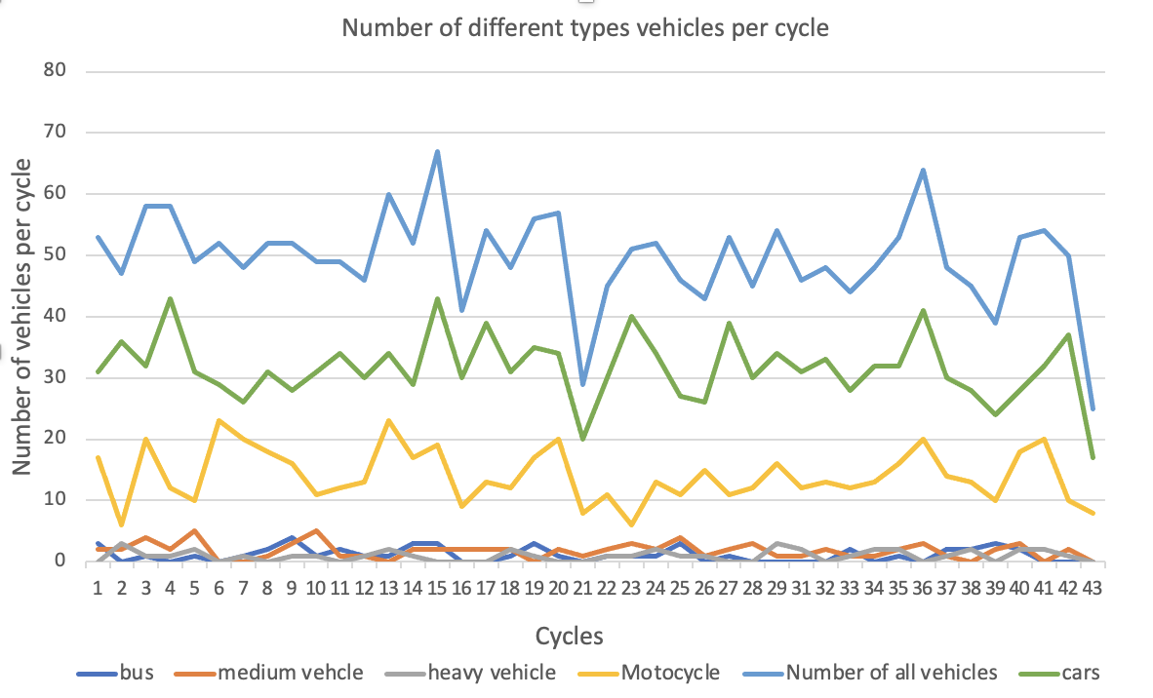

Figure 9. The number of vehicles for different vehicle types.

In statistics, linear regression is a linear approach for modeling the relationship between a scalar response and one or more explanatory variables (also known as dependent and independent variables). Here we use linear regression to find the relationship between the ratio of buses (or other vehicle types) during a specific period and the saturation flow rate.

**4.5.1 Relationship between bus ratio and saturation flow**

Using the data from Table 6, we generated the scatter plot with the estimated trend and functions, seen from Figure 10.

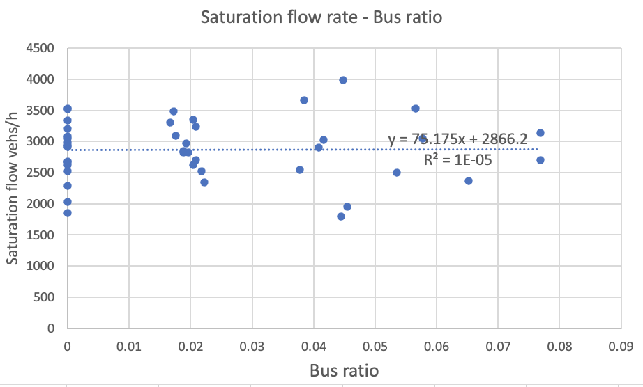

Figure 10. Relationship between bus ratio and saturation flow.

Table 7. Coefficients and P-value analysis.

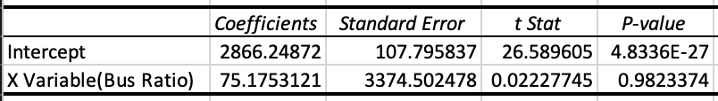

From Figure 10, the trend is just a flat line and from R squared and q-value we know that the results are not significant.

**4.5.2 Relationship between bus+HV+MV ratio and saturation flow**

Since the effect of buses is not significant to the saturation flow rate, we add heavy vehicles and medium vehicles to get ratios of three type vehicles as a new variable. Through linear regression, we got the relationship shown in Figure 11. From the regressed blue line, we can see that there exists a negative relationship between the ratio of vehicles with three types and the saturation flow rate, which is the same as we expected. From Table 8, we know that the results are still not significant.

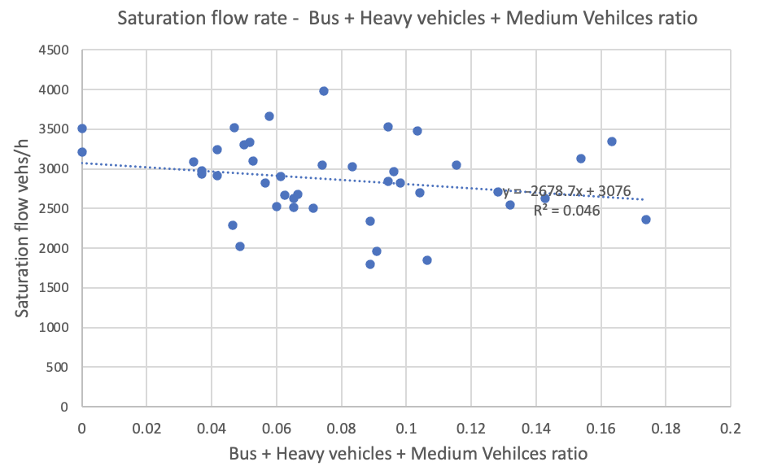

Figure 11. Relationship between bus ratio and saturation flow

Table 8. Coefficients and P-value analysis

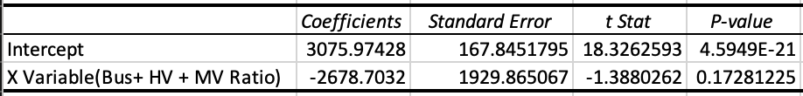

**4.5.3 Relationship between motorcycle ratio and saturation flow rate**

From Figure 9, we found that the ratio of motorcycles is relatively high compared with other vehicles. Thus, we explored the relationship between the ratio of motorcycles and the saturation flow rate. From Figure 12, we found that there exists a positive relationship between the saturation flow rate and motorcycle ratio, and p-value is low indicating that the result is significant.

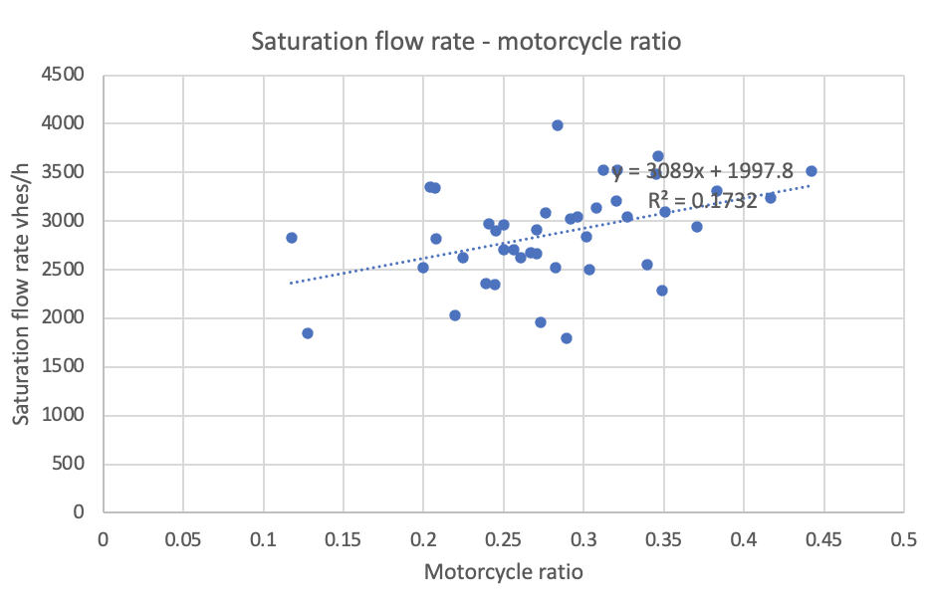

Figure 12. Relationship between motorcycle ratio and saturation flow rate.

Table 9. Coefficients and P-value analysis

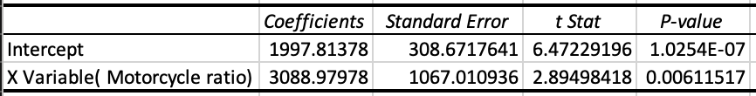

1. **Conclusion and Future Work**

From the numerical analysis, we can conclude:

1. Bus ratio is small, it can not affect the saturation flow a lot. Linear regression results are not significant.
2. Considering the sum of bus ratio, heavy vehicle ratio and medium vehicle ration together, it seems like when the ratio is higher, the saturation flow is lower, because these vehicles would increase mean saturation headway.
3. Since there are lots of motorcycles, when the ratio of motorcycles increases, saturation flow also increases. This is because motorcycles could decrease mean saturation headway.

For the future work, we plan to:

1. Add more data, considering other districts’ data.
2. Consider other factors’ effects on saturation flow. For example, the back of queue of the the former intersection reaches to the current intersection.
3. Use other models to find the relationships between bus ratio and saturation flow.

**References**

[1] Fitzpatrick, K., Hall, K., Perkinson, D., Nowlin, L., Koppa, R., 1996. Guidelines for the Location and Design of Bus Stops. TCRP Report 19, Transportation Research Board of the National Academies, Washington D.C.

[2] Barmpounakis, Emmanouil, and Nikolas Geroliminis. "On the new era of urban traffic monitoring with massive drone data: The pNEUMA large-scale field experiment." Transportation research part C: emerging technologies 111 (2020): 50-71.